[TEAM OneTen]

**[Aromy Software]**

**Business System - ITERATION 2 Report**

**[VERSION 2]**



**PREPARED BY**

* Rui Qin 30874157
* Shangqian Du 31121632
* Pei Ern Cassandra Tong 31509509
* Eugene Aquino 27841898
* Daniel Phelan 29732638

[ 15th September , 2022 ]

# INTRODUCTION

This report aims to provide an overview of the deliverables in the second iteration. The overall project goal is to deliver a functional website for Aromy to efficiently manage its business. In this iteration, we will be focusing on building onto the current system to develop more functionalities to streamline the business processes and provide a baseline for future growth and expansion. Whilst further developing on some of the functionalities made in Iteration 1, improving these processes and fleshing these concepts into more practical functionalities.

The main components of this report includes:

1. An overview of the business requirements for iteration 2
   1. Build on previous functionality from Iteration 1
2. The personas of the users involved in this iteration
3. A project timeline scheduled with the dates for team meetings and review iteration
4. Feedback Notes after the presentation

| CURRENT ITERATION OVERVIEW | |
| --- | --- |
|  | **Admin User Interface** |
| 1.1 | Introduce Product categories and product information |
| 1.2 | Automated deduction to the SOH when an order is made in the orders page. |
| 1.3 | Expand upon the low stock re-order report (add on update SOH) |
| 1.4 | Develop the order page |
| 1.5 | Manually send email after the order is paid by the customer |

# ITERATION TIMELINE

| FORMAL MEETINGS | DATE | ATTENDEES |
| --- | --- | --- |
| Iteration 2 Presentation | 12th September 2022 | Livia (Product Owner) & Team OneTen (All members) |
| Iteration handover for acceptance and integrity testing | 3rd October 2022 | Livia (Product Owner) & Team OneTen (All members) |
| Retrospective Artifacts Submitted | 10th October 2022 | Livia (Product Owner) & Team OneTen (All members) |
| Post-Implementation Review | 10th October 2022 | Livia (Product Owner) & Team OneTen (All members) |

# PERSONAS

# 

# 

# 

# 

# 

# 

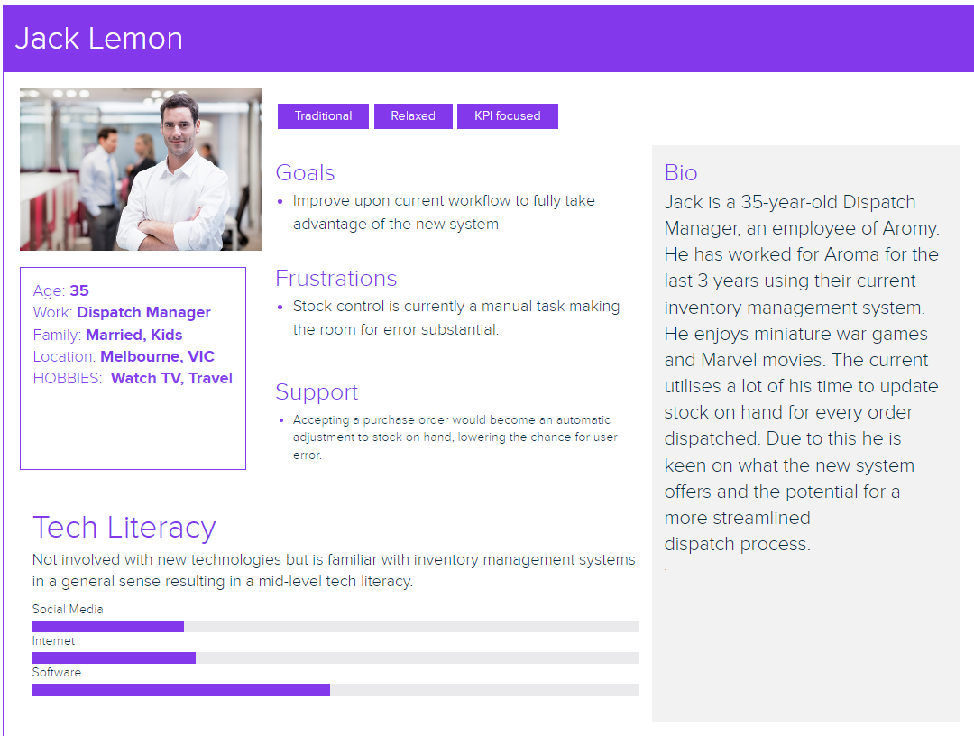

# 

# 

# 

# CLIENT FEEDBACK

Aromy would like the team to focus more on the fundamental business processes rather than wider features added and discussed to be implemented.

This includes ensuring the site features automatic stock reductions throughout the whole site, such as if an order was made in the orders tab, the products ordered would be automatically calculated, and the deductions reflected in the products page. This would allow the reduction of manual activities by Aromy admin, so the SOH levels are automatically reflected and as products hit these redlines, admin can place new orders. Furthermore, on the orders page, the client asked to have more simple business functionality which allows product items to be added to orders, with product quantity to be added as well, automatically calculating the prices of these products and ultimately the cost of orders.

The Client would also like the current website colour scheme to be changed from the black and blue scheme, to reflect better web acceessibility standards so everything can be viewed and seen much clearer.

The Client would like the database/lists to be more reflective of actual products Aromy might sell, rather than placeholder names.

The Client would also like the website to have more edit functionality, so customers and customer details can be modified more simply through a drop down function.98

SUMMARY

Please contact the team or the client liaison with any questions or concerns you may have after seeing the showcase of your product. We are delighted to adjust or fulfill your business needs. We are looking forward to our next meeting to understand more about your business requirements.

Cassandra Tong,

Client Liaison

[pton0008@student.monash.edu](mailto:pton0008@student.monash.edu)

On behalf of team OneTen.